|  |  |  |
| --- | --- | --- |
|  | [**curriculum.newvisions.org/social-studies**](https://curriculum.newvisions.org/social-studies)  Timothy Lent - [tlent@newvisions.org](mailto:tlent@newvisions.org)  Kameelah Rasheed - [krasheed@newvisions.org](mailto:krasheed@newvisions.org) |  |
| **Please Read:** We encourage all teachers to **modify** the materials to meet the needs of their students. To create a version of this document that you can edit:  1. Make sure you are signed into a Google account when you are on the resource.  2. Go to the "File" pull down menu in the upper left hand corner and select "Make a Copy." This will give you a version of the document that you own and can modify. | | Untitled drawing (10).jpg |
| **Teacher Overview:** *What was the ethnic and religious composition of the Ottoman Empire? Why did the empire have this ethnic and religious composition?* | | |
| [**Go directly to student-facing materials!**](#kix.uqg93d7vx3bm) | | |

|  |  |  |  |  |
| --- | --- | --- | --- | --- |
| **noun_713136_652c90.png** | SQ 2. [What was the geographic and historical context for the founding of the Ottoman Empire?](https://docs.google.com/document/d/1FmL6D-p7VN9PhIC8OXVjoWXjPUgipnU4_k2M9pldHZ0/edit) | **SQ 3. What was the ethnic and religious composition of the Ottoman Empire? Why did the empire have this ethnic and religious composition?** | SQ 4. [What was the Ottoman conquest of Constantinople? Why was the Ottoman conquest of Constantinople a turning point?](https://docs.google.com/document/d/1S81LuwTjkWaUDcsAaCziSUa7iznwqD4xFSLkulpm7Is/edit) | **noun_713139_652c90.png** |

|  |  |
| --- | --- |
|  | **Unit Essential Question(s):** How did the Ottoman Empire and Ming Dynasty gain, consolidate, and maintain power? | [**Link to Unit**](https://curriculum.newvisions.org/social-studies/course/9th-grade-global-history/ottoman-and-ming-pre-1600/) |
| **Supporting Question(s):**   * What was the ethnic and religious composition of the Ottoman Empire? Why did the empire have this ethnic composition? |
| **Objective(s):**   * **Describe** the ethnic and religious composition of the Ottoman Empire. * **Explain** why the Ottoman Empire have this religious and ethnic composition. |

**1.** [**NYS Social Studies Framework:**](https://www.engageny.org/resource/new-york-state-k-12-social-studies-framework)

|  |  |  |
| --- | --- | --- |
| **Key Idea** | **Conceptual Understandings** | **Content Specifications** |
| **9.7 THE OTTOMAN EMPIRE AND THE MING DYNASTY PRE-1600:** Islam, Neo-Confucianism, and Christianity each influenced the development of regions and shaped key centers of power in the world between 1368 and 1683. The Ottoman Empire and the Ming Dynasty were two powerful states, each with a view of itself and its place in the world.  (Standards: 2, 3, 4, 5; Themes: ID, MOV, GEO, SOC, GOV, EXCH) | 9.7b The dominant belief systems and the ethnic and religious compositions of the Ottoman Empire and the Ming Dynasty affected their social, political, and economic structures and organizations. | Students will analyze how the ethnic and religious compositions of the Ottoman Empire and the Ming Dynasty were reflected in their political and societal organizations. |

**2. Social Studies Practices**

|  |  |
| --- | --- |
| [**NYS Social Studies Practices**](https://docs.google.com/document/d/1BbSxR3Zm2iz30sd2QG63zzMpLHbirSHoSzJTe1YL9YA/edit) | [**New Visions Student Social Studies Practices**](https://docs.google.com/document/d/1wIIu9GwbUfjfvY-frgxKSQeHytikWeWAcByAM273RoQ/edit) |
| **Gathering, Using and Interpreting Evidence** (A5, A7)  **Chronological Reasoning and Causation** (B1)  **Comparison and Contextualization** (C3, C5, C6)  **Geographic Reasoning** (D1, D2, D5) | |  |  | | --- | --- | |  |  | | **Predict** | **Contextualize** | |
|
|
|
|
|
|
|

**3. Common Core**

|  |  |  |
| --- | --- | --- |
| **Reading** | **Writing** | **Speaking and Listening** |
| **Craft and Structure:** [**CCSS.ELA-LITERACY.RH.9-10.4**](http://www.corestandards.org/ELA-Literacy/RH/9-10/4/)**:** Determine the meaning of words and phrases as they are used in a text, including vocabulary describing political, social, or economic aspects of history/social science. **Integration of Knowledge and Ideas:** [**CCSS.ELA-LITERACY.RH.9-10.7**](http://www.corestandards.org/ELA-Literacy/RH/9-10/7/)**:** Integrate quantitative or technical analysis (e.g., charts, research data) with qualitative analysis in print or digital text. | **Text Types & Purposes:**  [**CCSS.ELA-LITERACY.WHST.9-10.1**](http://www.corestandards.org/ELA-Literacy/WHST/9-10/1/)**:** Write arguments focused on *discipline-specific content*. | **Comprehension and Collaboration:** [**CCSS.ELA-LITERACY.SL.9-10.1**](http://www.corestandards.org/ELA-Literacy/SL/9-10/1/)**:** Initiate and participate effectively in a range of collaborative discussions (one-on-one, in groups, and teacher-led) with diverse partners on grades 9-10 topics, texts, and issues, building on others' ideas and expressing their own clearly and persuasively. |

|  |
| --- |
| **Associated Classroom Posters** |
| [Student Social Studies Practices Poster](https://docs.google.com/document/d/1AGAFxRwz0ZPMKcSJ08zErSzXMY51ReYNVk2CdejetgQ/edit) |

|  |  |
| --- | --- |
| **Objective:** | **What was the ethnic and religious composition of the Ottoman Empire? Why did the empire have this ethnic and religious composition?**   * **Describe** the ethnic and religious composition of the Ottoman Empire * **Explain** why the Ottoman Empire have this religious and ethnic composition |

|  |  |
| --- | --- |
| **Contextualize**  **Predict** | **Introduction: Who were the Ottomans?**  **➡ Directions:** Examine the images below, then complete see-think-wonder protocol. |

Studio Portrait of Models Wearing Traditional Clothing from the Province of Iles d'Archipel (Islands of the Archipelago), Ottoman Empire (1873)

Source: <http://www.wdl.org/en/item/337/#q=ottoman>

|  |  |  |
| --- | --- | --- |
| **See**  List three things you ***see*** in the image above. | **Think**  Based on your observations, what do you ***think*** the people in the Ottoman Empire were like? | **Wonder**  Write two questions you have about the image above. |
|  |  |  |

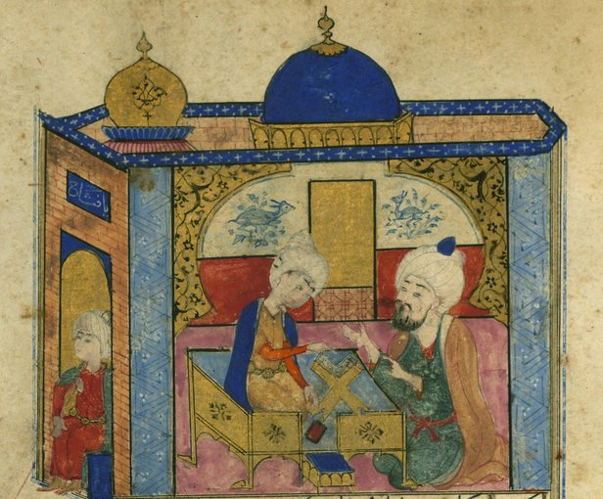

Ottoman Turkish Version of “Sindbād-nāmah”

Description: This work is an Ottoman illustrated and illuminated copy of the Tuhfet ül-ahyār, which is an Ottoman Turkish version of the well-known story of Sinbad (Sindbād-nāmah) the Wise, a story written in the Islamic Abbasid Caliphate about the fictional character’s adventures sailing in the Indian Ocean Complex.

[Image](https://www.wdl.org/en/item/9212/#q=ottoman) is courtesy of The Walters Art Museum’s Digital Walters and is published under a CC-BY License.

|  |  |  |
| --- | --- | --- |
| **See**  List three things you ***see*** in the image above. | **Think**  Based on your observations, what do you ***think*** the people in the Ottoman Empire were like? | **Wonder**  Write two questions you have about the image above. |
|  |  |  |

|  |
| --- |
| Diploma Description: This ijazah, or diploma of competency in Arabic calligraphy, was written by 'Ali Ra'if Efendi in the Ottoman Empire in 1791. The top and middle panels contain a saying (hadith) attributed to the Prophet Muhammad. It reads: "Secret charity quenches the wrath of the Lord. / The best of you is the best for his family. / The best of the followers is Uways" (1790 CE).  [Image](https://commons.wikimedia.org/wiki/File:Ijazah_(Arabic_calligraphy_diplom).jpg) is courtesy of Wikimedia Commons and is considered public domain in the United States |
|

|  |  |  |
| --- | --- | --- |
| **See**  List three things you ***see*** in the image above. | **Think**  Based on your observations, what do you ***think*** the people in the Ottoman Empire were like? | **Wonder**  Write two questions you have about the image above. |
|  |  |  |

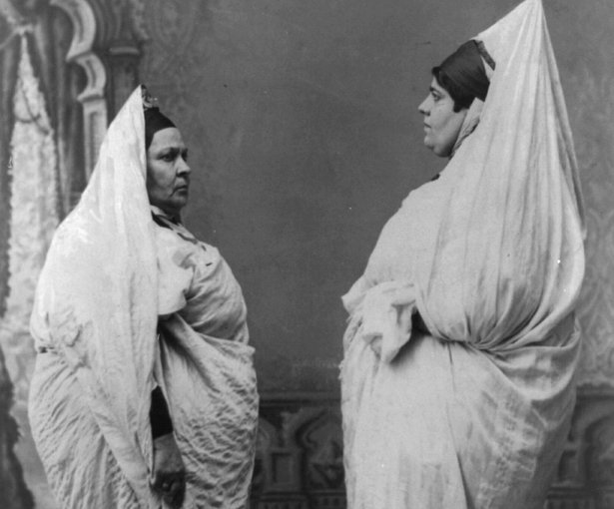

Two Jewish Women Standing, Facing Each Other, in Tunisia.

Description: This photograph presents two Jewish women in Tunisia [North Africa], a country that was a French protectorate at the time, although formally a territory of the Ottoman Empire. (1900).

[Image](https://commons.wikimedia.org/wiki/File:Two_Jewish_women_standing,_facing_each_other,_in_Tunisia.png) is courtesy of Wikimedia Commons and is considered public domain in the United States.

|  |  |  |
| --- | --- | --- |
| **See**  List three things you ***see*** in the image above. | **Think**  Based on your observations, what do you ***think*** the people in the Ottoman Empire were like? | **Wonder**  Write two questions you have about the image above. |
|  |  |  |

|  |  |  |  |  |  |  |  |
| --- | --- | --- | --- | --- | --- | --- | --- |
| As the Ottoman Empire grew, new people, particularly non-Muslims, became part of the empire. The Ottoman Empire was **diverse** and composed of **three major religious and ethnic groups**:   |  |  |  | | --- | --- | --- | | **Muslims** | **Christians** | **Jews** | | **Flashback:** What is one similarity between Muslims, Christians and Jews?\_\_\_\_\_\_\_\_\_\_\_\_\_\_\_\_\_\_\_\_\_\_\_\_\_\_\_\_\_\_\_\_\_\_\_\_\_\_\_\_\_\_\_\_\_\_\_\_\_. | | |   Although conversion to Islam was not demanded of the conquered, many Christians and a few Jewish people voluntarily converted to have full rights in the empire. Those who did not convert continued to practice their old religions without restriction.  For centuries, the Ottoman Empire was the refuge of the Jewish people of Europe who did not have the freedom of religion in Europe that the citizens of the Ottoman Empire did. Jews expelled from Spain in 1492 found refuge in the Ottoman territory, where the sultan decreed they should be welcomed.  This passage was adapted by New Visions from the [Ottoman Empire](http://www.newworldencyclopedia.org/entry/Ottoman_Empire) in New World Encyclopedia which is published under the CC-BY-SA 3.0 license.; Crescent and star [image](https://thenounproject.com/search/?q=islam&i=583013) by Hea Poh Lin is published on the Noun Project under a CC BY license.; Cross [image](https://thenounproject.com/search/?q=cross&i=1028417) by Pundimon is published on the Noun Project under a CC BY license; Star of David [image](https://thenounproject.com/search/?q=jewish%20star&i=466304) by Yu Luck is published on the Noun Project under a CC BY license.   |  | | --- | | **How were non-Muslims treated in the Ottoman Empire?**  **For centuries, why did Jewish people migrate to the Ottoman Empire?** | |

|  |  |
| --- | --- |
| **FA** | **SQ 3:**  What was the ethnic and religious composition of the Ottoman Empire? Why did the empire have this ethnic and religious composition?  **➡ Directions: Using evidence from the documents above, respond to the task below in the space provided.** |

|  |  |
| --- | --- |
| **Contextualize** | **Task 1:** Describe the ethnic and religious composition of the Ottoman Empire.  **Task 2:** Describe the reasons for the diverse ethnic and religious composition of the Ottoman Empire. |
|